**Unit Three: Exploring Holidays Around the World**

**Lesson 10: New Year’s Eve Around the World**

Name: __________________________________ Date: _______________________

1. **Use the letters in the word CELEBRATIONS to make as many words as you can.**

| rain |  |  |
| --- | --- | --- |
|  |  |  |
|  |  |  |
|  |  |  |
|  |  |  |

1. **Choose five words from the above list and use each in a sentence in the topic of celebrations.**

___________:________________________________________________________________________________:________________________________________________________________________________:________________________________________________________________________________:________________________________________________________________________________:_____________________________________________________________________



Name: __________________________________ Date: _______________________

1. **Answer the following questions:**
2. When do you celebrate New Year’s Eve?

___________________________________________________________________________

1. Where do you spend the evening?
2. Who do you spend this special evening with?

__________________________________________________________________________

1. How do you prepare yourself for it?

___________________________________________________________________________

1. What activities do you do together?

__________________________________________________________________________

1. **Use the answers you wrote in the above exercise to write a short paragraph about how you celebrate the New Year’s Evening.**

**_______________________________________________________________________________________________________________________________________________________________________________________________________________________________________________________________________________________________________________________________________________________________________________________________________________________________________________________________________________________________**

Name: ____________________________________ Date: ____________________

1. **Add (-ed) and (-ing) to the following list of verbs.**

| **Verb** | **+ ed** | **+ ing** |
| --- | --- | --- |
| **bake** |  |  |
| **smile** |  |  |
| **visit** |  |  |
| **jump** |  |  |
| **sob** |  |  |
| **tap** |  |  |
| **stop** |  |  |
| **celebrate** |  |  |
| **race** |  |  |
| **climb** |  |  |

1. **Use the following verbs in meaningful sentences.**
2. skipped: ____________________________________________________________________
3. planning: ____________________________________________________________________
4. hopped: _____________________________________________________________________
5. traveling: ___________________________________________________________________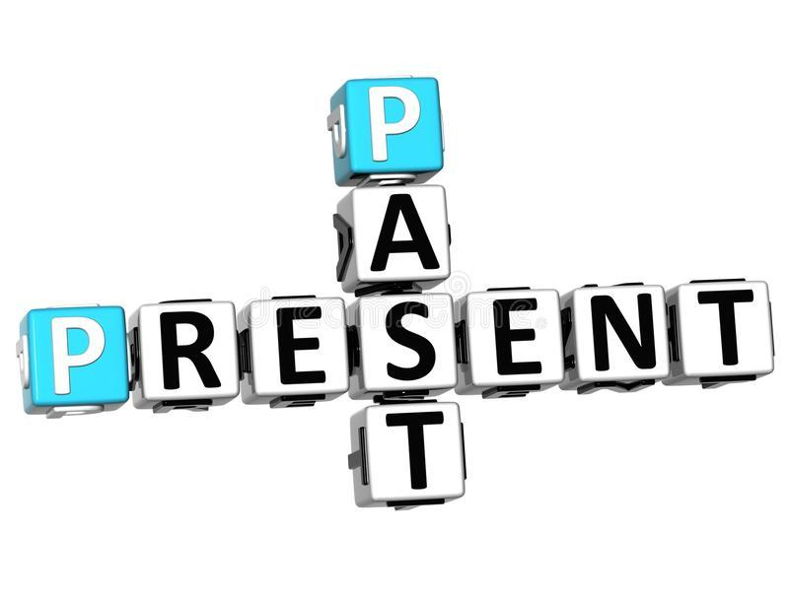

Name: ____________________________________ Date: ____________________

**Everyone hopes for the New Year to be better. People list down a number of goals and aims that they would like to achieve in the upcoming year. They also have their own hopes and desires that they would like to be true. Now, it is your turn to list down three hopes and three goals you have for the New Year.**

Goals:

1. ___________________________________________________________________________
2. ___________________________________________________________________________
3. ___________________________________________________________________________

Hopes:

1. ___________________________________________________________________________
2. ___________________________________________________________________________
3. ___________________________________________________________________________

